Assignment 1
(Shell Scripts)
Submission Date : 17.12.2025
Name: Vishnu Nagarajan S
Email: vishnunagaraj808@gmail.com

1️⃣ Number Classification (if + function) :
Shell Script:
check_number() {
num=$1
if [ $num -gt 0 ]; then
echo "$num is Positive"
elif [ $num -lt 0 ]; then
echo "$num is Negative"
else
echo "$num is Zero"
fi
}
read -p "Enter a number: " n
check_number $n
output:
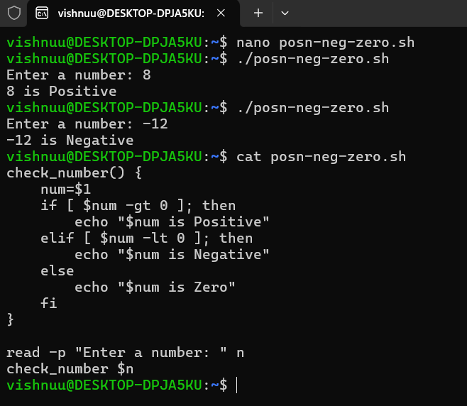
--------------------------------------------------------------------------------------------------------------------------------
2️⃣ Factorial of a Number (while + function) :
Shell Script:
factorial() {
num=$1
fact=1
i=$num

while [ $i -gt 0 ]
do
fact=$((fact * i))
i=$((i - 1))
done

echo "Factorial of $num is $fact"
}
read -p "Enter a number: " n
factorial $n
output :
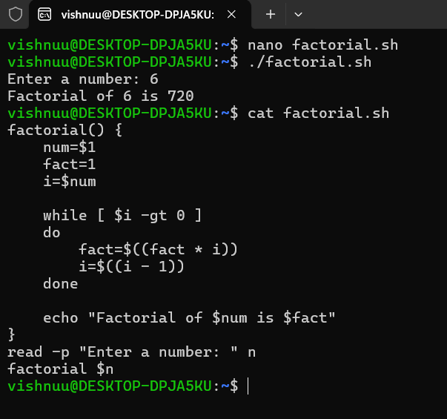
--------------------------------------------------------------------------------------------------------------------------------
3️⃣ Sum of N Numbers (for + function) :
Shell Script:
sum_numbers() {
n=$1
sum=0
for (( i=1; i<=n; i++ ))
do
sum=$((sum + i))
done
echo "Sum of numbers from 1 to $n is $sum"
}
read -p "Enter a number: " num
sum_numbers $num
output:
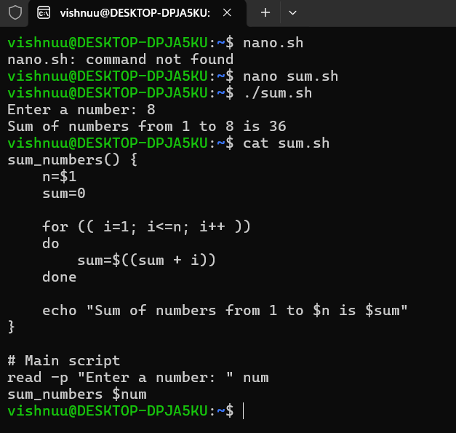
--------------------------------------------------------------------------------------------------------------------------------
4️⃣ Prime Number Check (if + for + function)
Shell script:
check_prime() {
num=$1
if [ $num -le 1 ]
then
echo "$num is not a prime number"
return
fi
for (( i=2; i<=num/2; i++ ))
do
if [ $((num%i)) -eq 0 ]
then
echo "$num is not a prime number"
return
fi
done
echo "$num is a prime number"
}
echo "Enter a number:"
read n

check_prime $n
output :
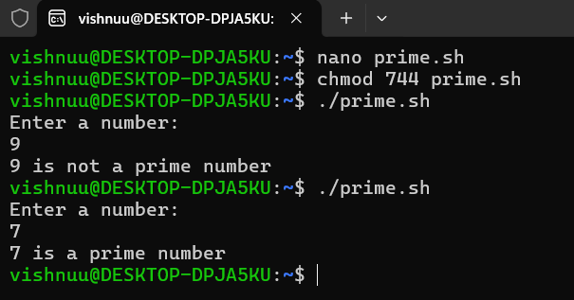
--------------------------------------------------------------------------------------------------------------------------------
5️⃣ Reverse a Number (while + if) :
Shell script:
echo "Enter a number:"
read num
rev=0
while [ $num -gt 0 ]
do
rem=$((num % 10))
rev=$((rev * 10 + rem))
num=$((num / 10))
done
echo "Reversed number is: $rev"
output :
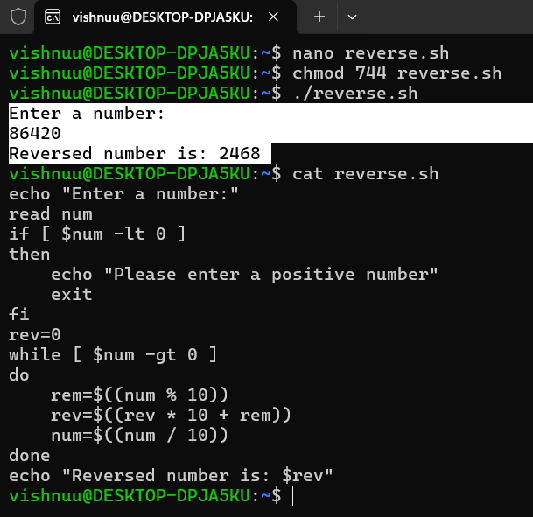
--------------------------------------------------------------------------------------------------------------------------------
6️⃣ File Existence & Permission Check (if + function) :
Shell Script :
check_file() {
file=$1
if [ -e "$file" ]
then
echo "File exists"
else
echo "File does not exist"
return
fi
if [ -r "$file" ]
then
echo "Read permission: YES"
else
echo "Read permission: NO"
fi
if [ -w "$file" ]
then
echo "Write permission: YES"
else
echo "Write permission: NO"
fi
if [ -x "$file" ]
then
echo "Execute permission: YES"
else
echo "Execute permission: NO"
fi
}
echo "Enter file name:"
read filename
check_file"$filename"
Output:
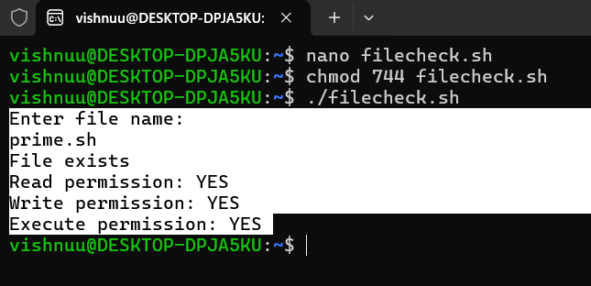
--------------------------------------------------------------------------------------------------------------------------------

7️⃣ Menu-Driven Calculator (while + case + function) :
Shell Script :
add() {
echo "Enter two numbers:"
read a b
echo "Result: $((a + b))"
}

subtract() {
echo "Enter two numbers:"
read a b
echo "Result: $((a - b))"
}

multiply() {
echo "Enter two numbers:"
read a b
echo "Result: $((a * b))"
}

divide() {
echo "Enter two numbers:"
read a b
if [ $b -eq 0 ]; then
echo "Division by zero is not allowed!"
else
echo "Result: $((a / b))"
fi
}
while true
do
echo "------ MENU ------"
echo "1. Add"
echo "2. Subtract"
echo "3. Multiply"
echo "4. Divide"
echo "5. Exit"
read -p "Enter your choice: " choice

case $choice in
1) add ;;
2) subtract ;;
3) multiply ;;
4) divide ;;
5) echo "Exiting..."; break ;;
*) echo "Invalid choice, try again." ;;
esac
echo
done
output :




